UML - the functional view - Use Case

Author

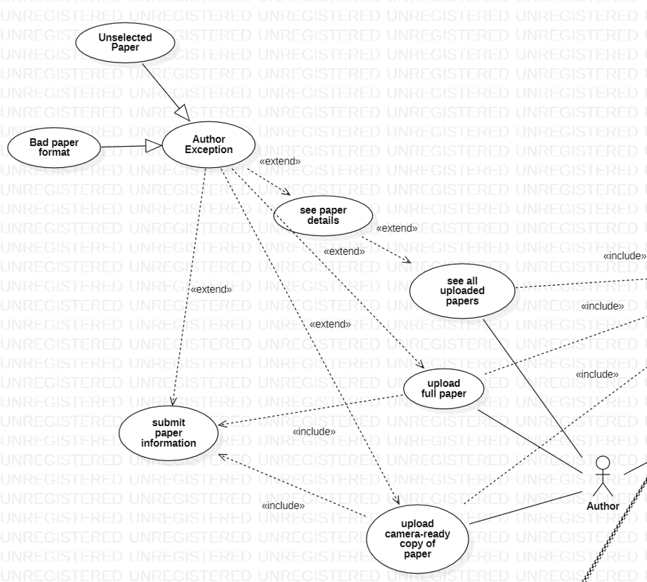

* **Name**: See all uploaded papers
* **Participating actor**: Author
* **Entry condition**: The actor Author must be sign in in order to see all uploaded papers
* **Exit condition**: Papers are shown
* **Flow of events**:
  + Author signs in
  + Author chooses to see all the papers
  + All the uploaded papers are shown
* **Special requirements**: none
* **Name**: Upload full paper
* **Participating actor**: Author
* **Entry condition**: Author must be sign in
* **Exit condition**: Paper should be uploaded in the system
* **Flow of events**:
  + Author signs in on the platform
  + Author chooses to upload a full paper
  + Check format:
    - The paper is not in a specific format => Bad paper format (Author Exception)
    - The paper is in the right format => the paper is uploaded
  + The paper is added to the system
* **Special requirements**: the paper must be in a specific format
* **Name**: See paper details
* **Participating acto**r: Author
* **Entry condition**: Author must be sign in on the platform
* **Exit condition**: Paper details must be shown to the author
* **Flow of events**:
  + Author signs in on the platform
  + Author sees all the uploaded paper
  + Author selects a specific paper to see its details (if the author does not select any paper=>Unselected paper (Author Exception))
  + The details of the paper are shown
* **Special requirements**: none
* **Name**: Submit paper information
* **Participating actor**: Author
* **Entry condition**: Author must be sign in on the platform
* **Exit condition**: Information must be submitted
* **Flow of events**:
  + Author signs in on the platform
  + Author chooses to upload a file
  + Author selects the file he wants to submit information
  + Author uploads the information to the paper (authors, their emails, addresses, keywords, and the topic of interest)
* **Special requirements**: none
* **Name**: Upload camera-ready copy of paper
* **Participating actor**: Author
* **Entry condition**: Author must be sign in on the platform
* **Exit condition**: Paper is uploaded
* **Flow of events**:
  + Author signs in on the platform
  + Author uploads camera-ready paper
  + The system accepts the paper
  + The camera-ready paper is uploaded
* **Special requirements**: none